Name:___________________________________________________________________ Date:________________________ Class:_________

Political Cartoon Analysis
WWI

Directions: Analyze each political cartoon and answer the questions below each picture. Do your best to answer what you see. You may catch something nobody else does.

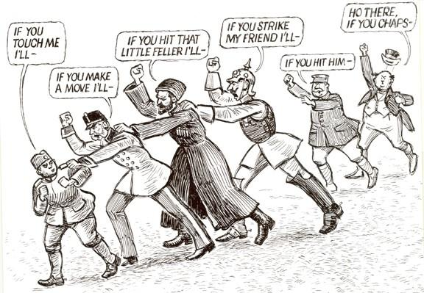

- Describe what you see in the cartoon.

- Which countries do you think represent the men in the middle? Why?

- How did etheir actions cause WWI?

- Who is absent from this event? Why are they absent and what does that tell you about the year?

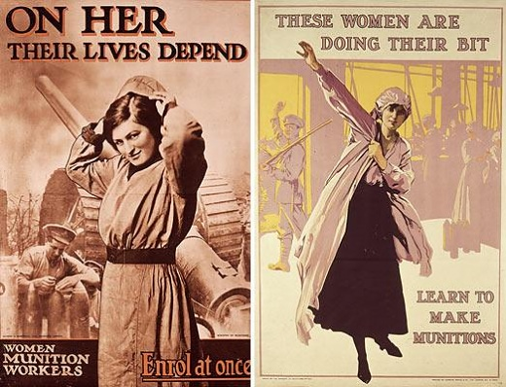

- Describe the two propaganda posters above.

- Who’s depending on these women to live? How are the women impacting their lives?

- What is the main purpose for posters like these in a war society?

- These posters cause for a sense of what among all Americans? (One word)

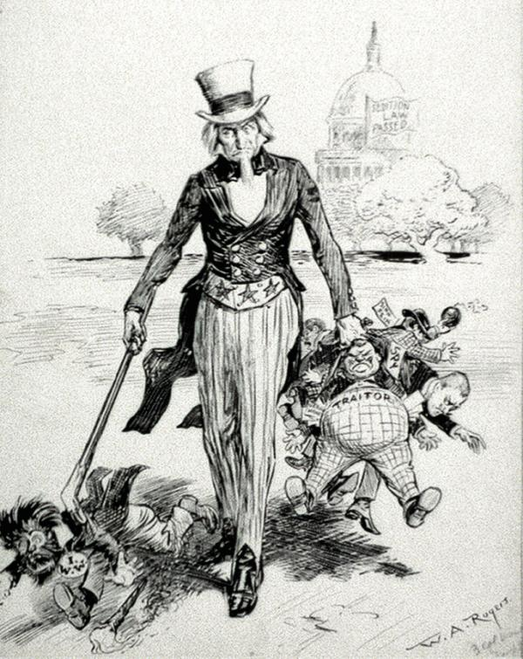

- Describe what is happening in this cartoon.

- Who is the man carrying the little people? Why is he so big?

- Who does the man on the left represent? Give me an example how labor unions were impacted during the war.

- The flag on the capitol building says “Sedition Law Passed”, what does that mean?

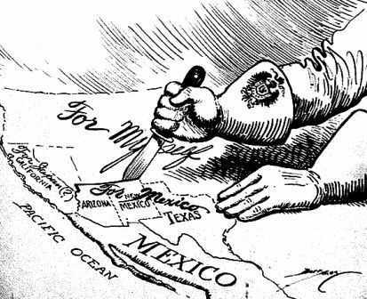

- Describe what is happening in this cartoon.

- Who is carving up the west of the United States? Why?

- What historical event is this cartoon portraying?

- What was America’s response to this letter?

