Outlines, Notetaking, and Reading the Chapters in U.S. History
Outline for Notes
You will be given an outline of each chapter. It will have only the main topics and sub-topics on there. There will be no fill-in the blank guided notes. It is time to take learn how to be an efficient note taker.
Don’t Be A Medieval Monk!!
Medieval monks copied texts by hand because there were no copy machines or computers! You don’t have that problem. Never write something down unless you can put it in your own words. It’s okay to copy a definition of a highlighted term down if you want but then write it down in your own words after you analyze what it is saying. The bottom line: If you can’t put something in your own words, you don’t know what it means!!
Don’t EVER, EVER, Ever use the GLOSSARY!!!!
The glossary is NOT a good place to learn vocabulary! Why you might ask? Because the glossary has the definitions isolated without CONTEXT or EXAMPLES. Vocabulary words are essential to what you need to learn; however they must be read, understood and learned in CONTEXT and with appropriate EXAMPLES. This happens in the reading of the text (Yes…the textbook) - not the glossary.
As you read, ask yourself: What is the most important word or words in a sentence, sentences or paragraph? Think of it about it like a sieve.
Think about “pouring all you have read” into that sieve. You want only the most important stuff staying in the basket while the unimportant filter out the bottom. Remember, if you read something and it is common sense or you already know it - you don’t necessarily need to put it in your notes.
To Boldly Go Where No Student Has Gone Before
Bold or italicized words - these words are always important for quizzes and tests. I would pay attention to these words. Most of these words will be on your hot topics or Id/vocabulary list. It’s not just about vocabulary either! Pouring all of the text through our sieve above should help you think about THE BIG IDEAS in the text.
Maps
Have you ever been reading a book or text and skipped the pages with a map on it? Well, don’t do that in here! Maps can answer questions that the text cannot. Plus, do you think we would have won any wars if we did look at a map. Critically analyze and think about the meanings of the maps. In fact, the state test will probably have a map on it somewhere, so it let’s not over look those maps.
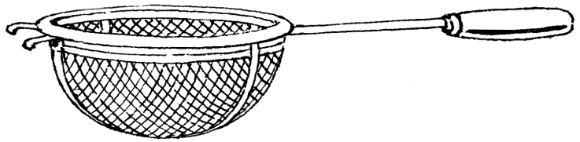

Study Skills
A little bit each day means not much the night before. Most students cram for an exam. Trying looking at what was done in class for 10-15 minutes each day. It doesn’t seem like much, but do the math. If you did this for three weeks, look at the numbers:
12.5 minutes X 10 days = 125 minutes 125/60 (minutes in an hour) = 2.08 hours How many of you study 4+ hours the night before an exam?
Make School an 8-5 Job!
Do you want to be successful and have a lot of fun? You really can do both. Just make school an 8-5 job. I will explain the details that will make school fund - and you will be successful too!
Don’t Take It Home Unless You Have Homework!
Hardly anyone ever listens to this one. Use your school time wisely. If you get 5 minutes free in a class, use it! (Doesn’t happen much) If you finish an exam in a class 25 minutes before the bell, be prepared. You need to start working on the next layer in you’re your student portfolio. Use that time to get done what needs to be done.
YOU WILL HAVE TO WORK IN THIS CLASS. I PROMISE THE REWARDS WILL COME IN DECEMBER WHEN YOU ACE THAT STATE TEST BECAUSE HARD WORK PAYS OFF.

