Cold War Political Cartoon Activity
Coach Haley
U.S. History
Fall 2016

Directions: Analyze the two political cartoons and answer the questions provided below.

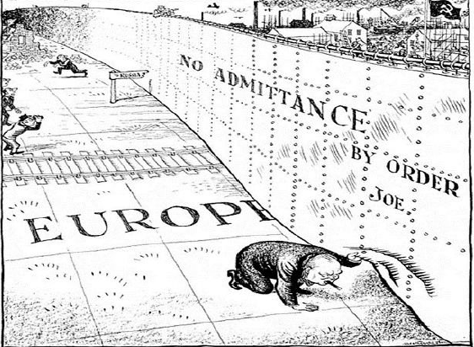

- Describe what you see in the photo.

- What does the wall separate? Who is looking under the wall?

- Who is Joe?

- Which side do you think is the East? How can you tell?

- What is the main point of this cartoon?
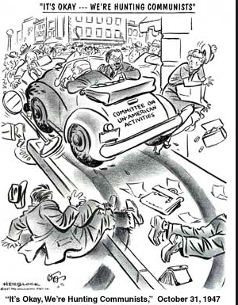

- Describe what you see in this political cartoon.

- What does the car represent? Who do you think is driving the car?

- What major event in American history is depicted in this cartoon?

- What does the title say about how the men are driving?

- What is the main idea of this Cold War political cartoon?

